**Process Support Page**

Meeting minutes:

We organized several meetings through Microsoft Teams, including preparing and recording presentations and designing our website.

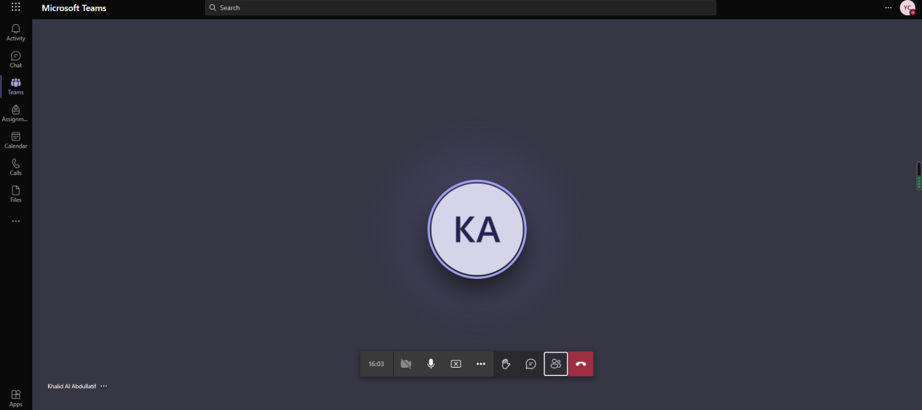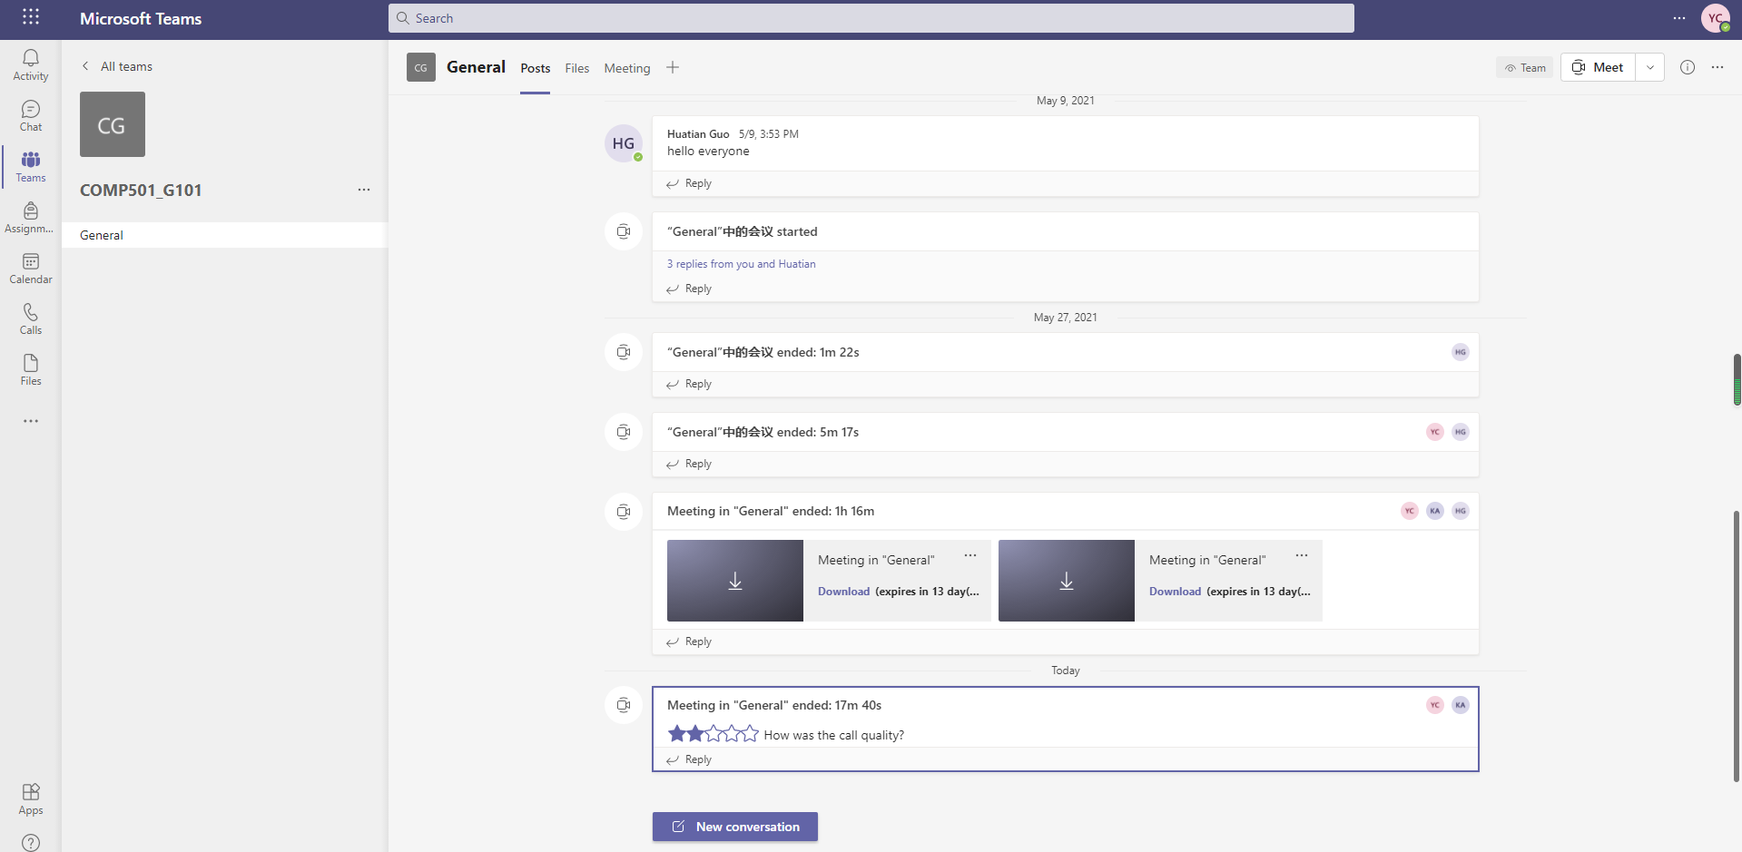

We also create a WeChat group to make conversation to draw up plans and follow up.

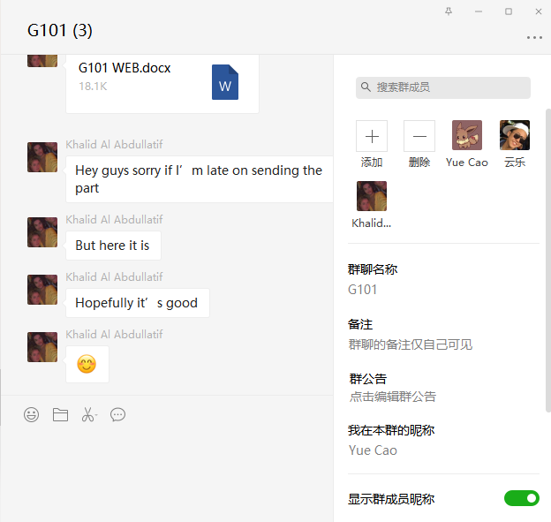

Our files are updated on the github:

<https://github.com/G1-G101/G1-G101.github.io>